**Design and Implementation of a Project Management API using Python and Blockchain Technology**

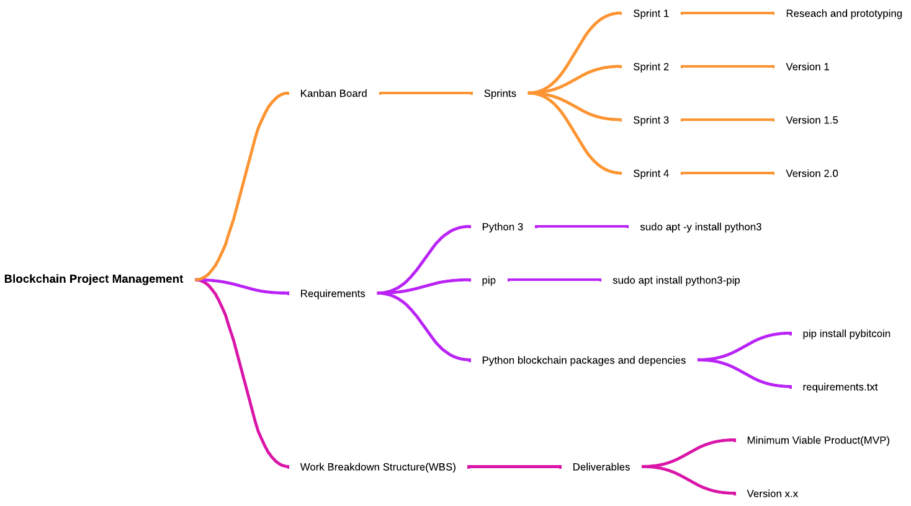

***Quick Overview:***

* Research python API development
* Research python blockchain development
* Build simple blockchain program
* Build simple API program
* Combine simple projects into a minimum viable product
* Unit testing with pytest
* Expand and deploy project

***Budget:***

The budget must cover the cost for development, time spent, and server space for deployment. The budget will come from the investors.

***Resources:***

Resources required include server space for deployment and computers for development. The development team will determine the required amount of server space needed as well as the computers needed for development.

***Stakeholder analysis:***

Stakeholders include business partners, investors, employees, potential customers looking for a project management API. The business partners and employees will have a high amount of influence. The investors will have some influence and interest. Therefore, we will keep them informed and they will be monitoring the project. Potential customers will not have much influence but will have a higher amount of interest and we should keep them informed.

***Rough outline:***

The beginning stage of the project will be spent researching the required technologies. The technologies include creating blockchain with python, API development, and project management tools. Once research is done, prototyping blockchain and an API will take place. The prototypes will help with understanding the technology before expanding the project to a minimum viable project. To keep the project on track we will use unit tests with python’s pytest package. Pytest will also help with the maintenance portion of the project. In order to finish by the end of this class, this project will be completed in about 3-4 sprints.

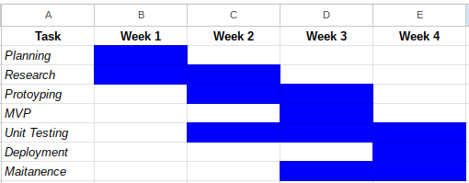

Gantt Chart

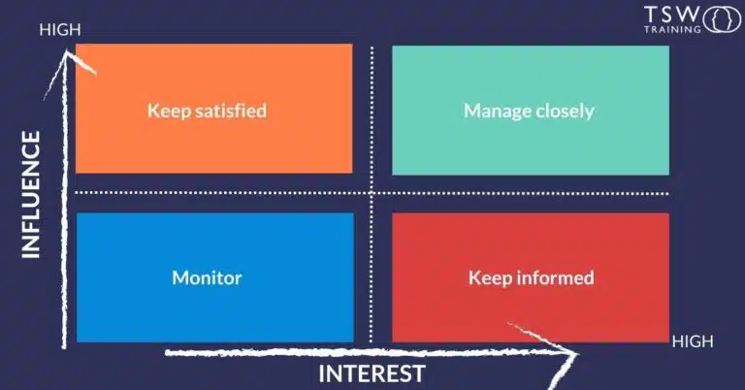

Stakeholder Analysis Chart